# Department of Computing

**EE433: Digital Image Processing**

# Lab 9: Spatial Filter Basics

**CLO4: Design and implement algorithms for digital image processing operations such as histogram equalization, enhancement and restoration, filtering, and de-noising**

# 

# Lab 9: Spatial Filter Basics

**Introduction**

This lab is an introduction to spatial filter basics.

**Objectives**

This lab will provide the concepts of filtering to the students.

**Tools/Software Requirement**

Python 2.7

**Description**

Filtering techniques are an important part of image processing systems, in particular when it comes to image enhancement and restoration. Here, we only consider linear and spatially invariant systems. We demonstrate that image g(x,y) resulting from the passing of image f(x,y) through such a system can be computed using a 2D convolution product with the system impulse response h(x,y).

Smoothing filters are used for blurring and noise reduction. Blurring may be implemented in preprocessing tasks to Blurring may be Implemented in preprocessing tasks to remove small details from an image prior to large object extraction.

**Lab Tasks**

**Task #1: Effect of averaging and the size of averaging filters**

Consider the following image. Apply averaging with a filter size of 3*3, 5*5, 15*15, and 35*35. A sample 3*3 averaging filter is given below.

|  |  |  |
| --- | --- | --- |
| 1 | 1 | 1 |
| 1 | 1 | 1 |
| 1 | 1 | 1 |



1/9 X

What do you observe when increasing the size of the filter and why?

Apply different weighted averaging filters on the same image and note down the effect they have on the input image. One weighted averaging filter is given below.

|  |  |  |
| --- | --- | --- |
| 1 | 2 | 1 |
| 2 | 4 | 2 |
| 1 | 2 | 1 |

1/16 X

**Task #2: Gaussian smoothing**

Apply the following Gaussian filter to the image given above. Here, the σ = 1.4. What impact do you think happen when the value of σ is increased? Don’t forget the normalizing factor while applying the given Gaussian filter.



**Task #3: Un-sharp Masking**

Perform un-sharp masking on the following image. Does this enhance the image? Try with at least two different smoothing methods. How does that affect the results?

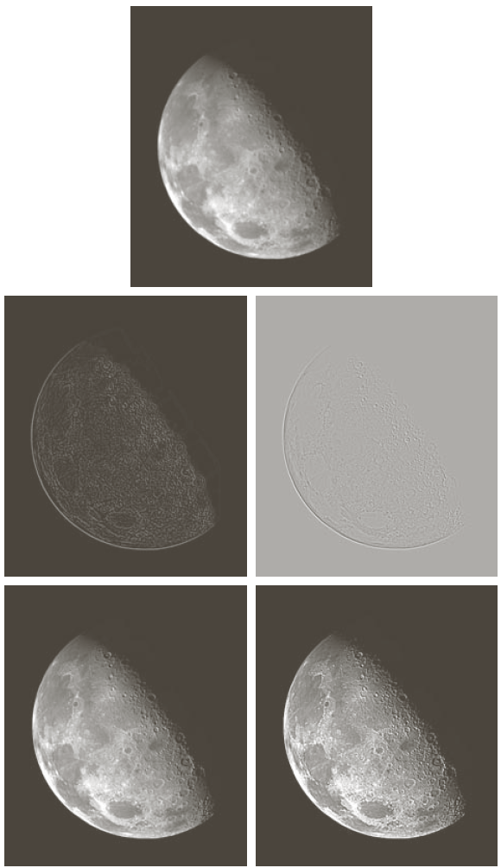

**Task #4: Removal of Salt and Pepper noise**

An image having salt and pepper noise is given below. Which filtering approach do you consider will suit best to remove the said noise? Apply the approach and show results.



**Deliverable**

Please make sure that you submit the following contents:-

A zipped folder containing all the .py files,all output images,a document containing code and output screenshots for all the output images.